WEDE5020

MATTHEW GEORGE TERBLANCHE

ST10488562

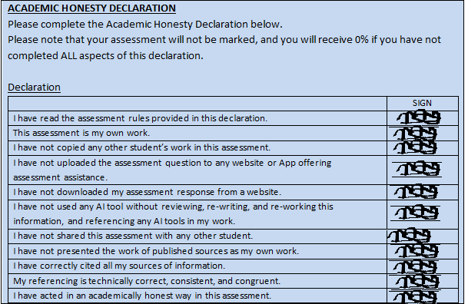

# TABLE OF CONTENTS

Contents

TABLE OF CONTENTS 2

1.Organisation Overview 3

2. Website Goals and Objectives 3

3. Current Website Analysis 3

4. Proposed Features 3

5. Design and User Experience 4

6. Technical Requirements 4

7. Timeline 4

8. Budget 5

Reference List 6

# 1.Organisation Overview

**Name**: The Kitchen Takeaways and Deli

**History**: The Kitchen Takeaways and Deli is a fast food establishment that was founded in Despatch in 2019.The business provides a wide array of dishes from many different cultures at affordable prices compared to big franchised fast food restaurants. This has allowed the business to expand further in Uitenhage and to build a positive local reputation.

**Mission Statement**: Provide delicious and affordable food to all customers.

**Vision Statement**: To become the most trusted destination for fresh and exquisite meals at affordable prices.

**Target Audience**: Teens and Adults aged 14-45 that come from working class backgrounds that want quick and affordable meals.

# 2. Website Goals and Objectives

**Goals**:

* Display the food option to more individuals
* Simplify the process of ordering food
* Build more trust within the community

**KPIs**:

* Increase in the businesses online engagement growing website by 50% engagement
* Achieve a 20% repeat customer rate
* Feature 5+ customer reviews

# 3. Current Website Analysis

There is no current website therefore the website I will be constructing will be the first website for this business

# 4. Proposed Features

* Interactive Menu
* Customisable Orders
* Location Map
* Help Section

# 5. Design and User Experience

**Colour Scheme**:

* Dark theme (#1A1A1A) with neon accents (#00FF88)

**Typography:**

* Font-family: Arial, sans-serif
* Heading: Style with bold text to emphasize the section titles

**Layout:**

* Header- This contains the logo,navigation bar, and a orderbutton
* Sections- Every section is styled with min-height:100vh for them to span the full viewport height
* Footer- This includes the copyright information and the social media links of the business

**Wireframes:**

* Homepage-This includes a welcome message and a brief description of the restaurant
* About us page-This include the about section of the restaurant
* Menu page-This has the menu that includes all the food offered by the restaurant
* Contact us page-Includes fields for name,email,and message with a send button if individuals need to contact the business with a query

# 6. Technical Requirements

**Hosting**: HostAfrica

**Booking System**: Mindbody API

**CMS**: Wordpress

**Languages**: HTML, CSS JavaScript

# 7. Timeline

**Week 1-2**: Research for part 1

**Week 3-6**: Doing part 1, Pre submission, Submitting part 1

**Week 7-10**: Research for part 2, Doing part 2

**Week 11-12**: Submitting part 2

# 8. Budget

**Development**: R3500

**Hosting/Maintenance**: R4320/year

**Marketing**: R10000

**Total**: R17820

# Reference List

1. **HostAfrica** (2023) *Web Hosting Prices in South Africa*. Available at: <https://hostafrica.co.za/web-hosting/> (Accessed: 18 March 2025).
2. **HubSpot** (2020) *The Ultimate Guide to KPIs*. Available at: [https://cdn2.hubspot.net/hubfs/2527762/KPI%20Week/KPI-Ebook.pdf](https://cdn2.hubspot.net/hubfs/2527762/KPI%2520Week/KPI-Ebook.pdf) (Accessed: 5 March 2025).
3. **Kinsta** (2023) *What is a Content Management System (CMS)?* Available at: <https://kinsta.com/knowledgebase/content-management-system/> (Accessed: 20 February 2025).
4. **Mindbody Developer Portal** (2023) *Mindbody API Documentation*. Available at: <https://developers.mindbodyonline.com/> (Accessed: 18 March 2025).
5. **New Perspective Studio** (2022) *What is the Cost of Creating a Website in South Africa?* Available at: <https://www.newperspectivestudio.co.za/wp/what-is-the-cost-of-creating-a-website-in-south-africa/> (Accessed: 15 March 2025).
6. **World Wide Web Consortium (W3C)** (2011) *Cascading Style Sheets Level 2 Revision 1 (CSS 2.1) Specification*. Available at: <https://www.w3.org/TR/CSS2/> (Accessed: 25 February 2025).
7. **World Wide Web Consortium (W3C)** (2014) *HTML5: A vocabulary and associated APIs for HTML and XHTML*. Available at: <https://www.w3.org/TR/html5/> (Accessed: 5 March 2025).
8. **World Wide Web Consortium (W3C)** (2014) *WAI-ARIA 1.1: Accessible Rich Internet Applications*. Available at: <https://www.w3.org/TR/wai-aria-1.1/> (Accessed: 10 March 2025).
9. **World Wide Web Consortium (W3C)** (2018) *CSS Flexible Box Layout Module Level 1*. Available at: <https://www.w3.org/TR/css-flexbox-1/> (Accessed: 15 March 2025).
10. **World Wide Web Consortium (W3C)** (2018) *CSS Transitions Level 1*. Available at: <https://www.w3.org/TR/css-transitions-1/> (Accessed: 18 March 2025).
11. **World Wide Web Consortium (W3C)** (2018) *Web Content Accessibility Guidelines (WCAG) 2.1*. Available at: <https://www.w3.org/TR/WCAG21/> (Accessed: 18 March 2025).
12. **World Wide Web Consortium (W3C)** (2021) *CSS Grid Layout Module Level 1*. Available at: <https://www.w3.org/TR/css-grid-1/> (Accessed: 12 March 2025).